RUSSIAN FEDERATION
MINISTRY OF DEFENCE

COMBINED ARMS ACADEMY
TRAINING CENTER

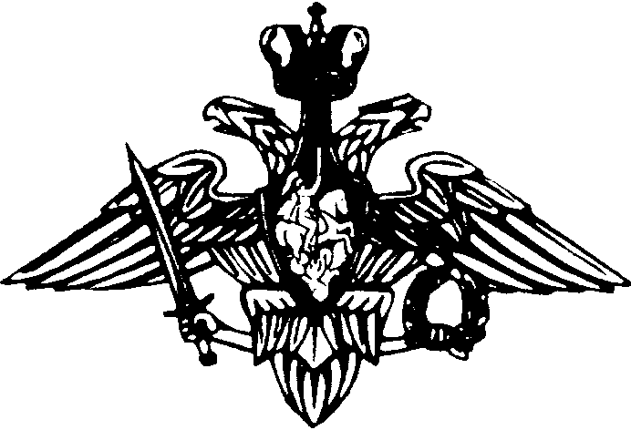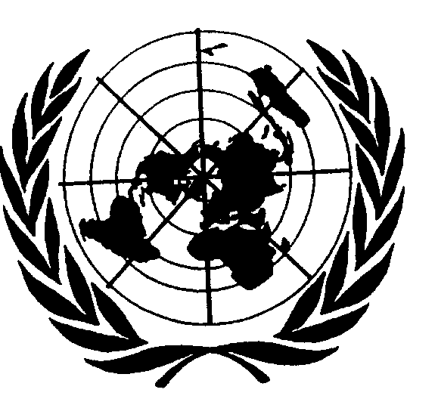

RUSUNMOC

RUSSIAN UNITED NATIONS MILITARY OBSERVER COURSE

2001

SOLNECHNOGORSK

MOSCOW, RUSSIA

GENERAL

1. Since 1975, the Russian United Nations Military Observer Training Course has been an integral part of Russia’s contribution to the UN peace-keeping operations. We are prepared to exchange our experiences with yours in the increasing field of the comprehensive peace-keeping training concept. I would like to invite students and visitors to Solnechnogorsk and I hope the stay with us will be interesting and rewarding. Welcome to RUSUNMOC !
Ilia Zarouba

Lt Col

RUSUNMOC Course Director

ABOUT THE COURSE

- Russia has participated in UN peace-keeping activities since 1973. The UN training centre was founded in 1975. The training centre is in charge of arranging the training for service in UN PKOs. Russian soldiers have served in UN PKOs in the capacity of Military Observers and members of Russian National Contingents. Russia has trained more than 700 Military Observers since 1975. The training of Russian Military Observers is executed immediately prior to their rotation. At present, they are trained at the Russian UNMO Training centre, collocated with the Higher Officers Training Course “Vystrel” at Solnechnogorsk, Moscow region. UNMO Training Courses are organized three times a year.

- There are about 20 students on each of these courses, which means in all 60 student officers on the courses per year. Not only Russian Military Observers receive training on these courses, but since 1996 an increasing number of officers from foreign countries undergo UN training in Solnechnogorsk. There have been participants from Canada, Denmark, Germany, Norway, Sweden, the UK and the USA. The duration of the course is 8 weeks for Russian students and 4 weeks for foreign students.

- The course prepares students for Military Observer and Staff Officer duties. It provides student officers with basic information about the United Nations, supplies general background information about current UN PKOs and prevailing local conditions, combined with instruction in the basics of peace-keeping. Students also rehearse and standardise their military skills. The main object of the training is the UNMO duties in the mission area. The training utilises personnel recently repatriated from or still serving with the UN, thus providing a guarantee for an updated training. The course is conducted in English.

- RUSUNMOC is, collocated with the Training centre of the Combined Arms Academy, located approximately 40 km North of Moscow (20 km North of Sheremetevo-2 International Airport), along the road to Saint-Petersburg.

- The modern training facilities of the Training centre, the excellent exercise ground, coupled with professional and experienced training personnel, form a framework for execution of even the most demanding training occasions.

- Training occasions are arranged three times a year for personnel who relive those who are returning from various UN missions. For each training occasion, the requisite number of personnel, fulfilling the necessary requirements of military professional skills, are called up. The students must be able to communicate in English, both verbally and in writing.

- The prevailing training organisation follows the principle of training personnel in accordance with current requirements and of sending them abroad shortly after the training period. Personnel replacement orders determine the number of personnel, which are called for training. Delivering of actual information on relevant peace-keeping operations and local conditions is the main objective of the training. The peace-keepers are also instructed in correct principles of attitude and approach combined with training in special fields. It is the duty of the RUSUNMOC to train personnel prior to peace-keeping service with a UN mission.

RUSUNMOC UN TRAINING STRUCTURE.

There are two main blocks in RUSUNMOC training procedure. They are as follows:

A: UN special training;

B: Basic military skill refresher training.

Block A includes the following subjects:

SUBJECTS RUSSIAN STUDENTS JOINT TRAINING
TRAINING

- History of UN peace-keeping 20 Hrs
operations

- Operational duties of UNMOs 42 Hrs

- UN radio voice procedures 22 Hrs 18 Hrs

- Military English 30 Hrs

- Safety, security & stress management 6 Hrs 6 Hrs

- Battlefield First-Aid 6 Hrs

TOTAL: 58 Hrs 92 Hrs

Block B includes the following subjects:

SUBJECTS RUSSIAN STUDENTS JOINT TRAINING
TRAINING

- Tactical training 4 Hrs 24 Hrs

- Reconnaissance 6 Hrs

- Military topography 6 Hrs 2 Hrs

- Mine awareness 4 Hrs 2 Hrs

- Driving and self-recovery 38 Hrs 22 Hrs

- Military materiel recognition 10 Hrs 6 Hrs

- Geopolitical survey 2 Hrs

- Computer training 20 Hrs

- Physical training 2 Hrs 2 Hrs

TOTAL: 92 Hrs 58 Hrs

For further information and application please contact Main Directorate of International Military Co-operation of Ministry of Defence of the Russian Federation

Col ALEXEY STEPANOV tel. 7-095-293-32-59

